No 2021 November Edition 14 November 2021

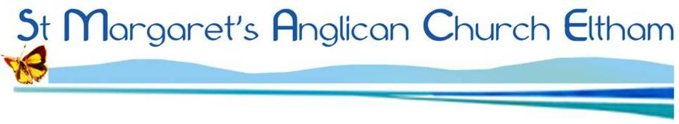



Celebrates parish life and reports important items from the most recent Parish Council meeting
Find us on the web at www.stmargaretseltham.org.au/ Facebook at www.facebook.com/stmargaretseltham
ACKNOWLEDGEMENT

St Margaret's Anglican Parish Eltham acknowledges the Wurundjeri people of the Kulin nation as the traditional custodians of the land on which we worship. We commit to working for reconciliation and justice for Aboriginal people. Diversity and inclusivity are important to us at St Margaret's.

O God, our Redeemer,
in our weakness we have failed
to be your messengers of forgiveness and hope:
renew us by your Holy Spirit,
that we may follow your commands
and proclaim your reign of love;
through Jesus Christ our Lord,
who lives and reigns with you and the Holy Spirit,
one God, now and for ever. Amen.
In This Issue

Christopher at Cockatoo
HeartEdge
Synod 2021
We are back
Do Justice
Anglicare
Roger Kerr
Parish Council report

Retiring collection
today for Anglicare

St Margaret’s Parish Annual Meeting
Sunday 21st November at 11:00am
Following 9:30am Service
It's that time of year again! We're preparing for the Annual Meeting which this year will be held on Sunday 21st November at 11am.
The meeting will be in person, and can also be joined online via Zoom, just stay on after the service.

Food collection
starting again.
Please add to the tub
in the Foyer each week.
Food goes to St Mark’s
Fitzroy and is
distributed by
Anglicare.

The Commissioning of Revd Christopher Garcia our former curate at Cockatoo (photos of Zoom service}

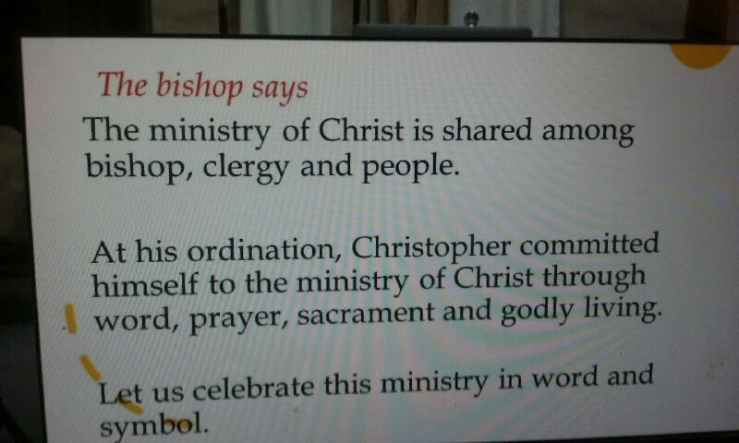

Oaths and Declarations with Bp Paul Barker

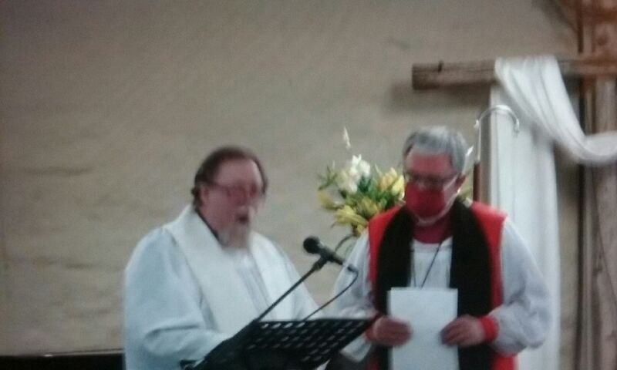

Welcomed by the congregation (only 1 present plus technical support) but many of us watching from home.

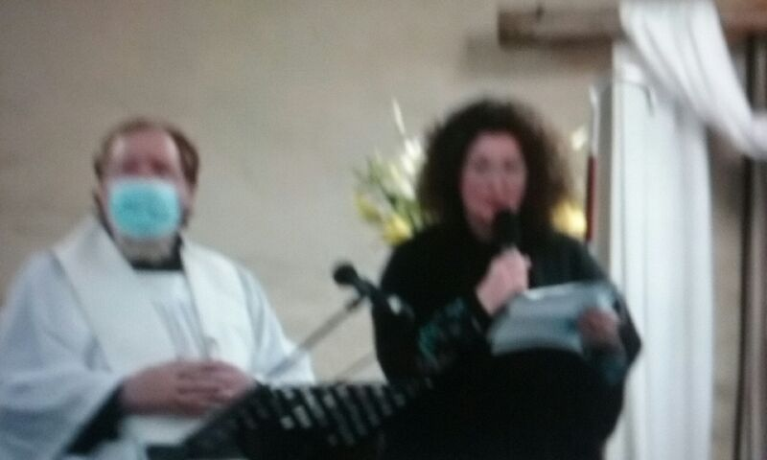

HeartEdge

St Margaret’s is on the brink of embracing an ethos in ministry that is both expansive and exciting. It invites us to reframe some of what we already do and to aspire to new a new state of mind as well. I have been reading and participating in discussions on the Revd Sam Well’s book A Future That’s Bigger Than The Past for about eighteen months. It has been an enlivening time. St Margaret’s is collaborating with St Georges East Ivanhoe which is a HeartEdge hub.
Sam Wells brings a new level of energy and life to Gospel messages. I’ve spent decades in church exposed to various programmes that aim to inspire and promote growth. Nothing seems to come close to Wells’ proposition that when believers embrace the gospel message and trust in the power of the Holy Spirt, there is no limit to what can be achieved. This is why he believes that the church’s future is bigger than its past.
Wells’ proposes four strands to church expansion. These are: Commerce, Culture, Compassion and Congregation. His vision is certainly complex as he engages in a detailed a well-researched exploration of the limitations of historic approaches to church growth.
For example, he challenges long-held attitudes to charity. Rather than giving to others in order to make them more like the prevailing church community, he suggests that we should recognise the giftedness of those outside of the church. This where the idea of hub or centre and the liminal or the edge comes into play. This is a different way of thinking. The HeartEdge approach doesn’t give step by step set of instructions on how to achieve change. It focuses on fostering a mind-set that promotes courage and a willingness to experiment. All that Sam Wells proposes is grounded in the belief that God is at work in the world. When we truly embrace this reality and believe in the Spirit, the church has all of the resources it needs to enable a future that is bigger than its past.
The recent questionnaire you recently completed gives an indication of your desires for our community in the future. You might like to join a Book Club reading Sam Well’s The Church Has A Future Bigger Than Its Past. Perhaps your gifts and talents in the areas of Commerce, Culture, Compassion or Congregation might provide the spark for us to reach out to the edge. Why not dip
your toe in the water and pick up the book? I should also tell you can view a set of videos of the book chapters delivered as the Chalmers Lectures. I’ve watched each one twice. They are brilliant!
Revd. Linda

RReRe Reflections on Synod 2021

In his address to the 2021 Synod the Archbishop warned that, with 550 people or more on line, patience, understanding and perseverance would be required to get through to the end of the week. He was right!

The huge volume of text to absorb (only available via the parish portal, not on paper) was overwhelming, and there were special on line sessions provided prior to Synod proper to assist us to appreciate the issues involved. These sessions were helpful to those able to access them.

As part of the review of diocesan processes and procedures there were several significant bodies of legislation that were outdated and needed to be revised/repealed to make them functional for the 21st century.

The on line voting procedure – once we had practiced it a few times – was effective and gave immediate results and feedback. Its anonymity, as opposed to the Cathedral voice or raised hands process, was good too.

Issues of the problems with the Diocesan Payroll process were aired and clearly these have been significant for some, but not all, parishes. Synod was assured the some improvements have already been made, and more are promised.

Work on safe ministry and professional standards continues, and the Clergy Review legislation created some anxiety as did the revision of the Archbishop Election Act. So many questions…Who should participate in the election and how? What should be the length of tenure? How many for a board of nominators? How to ensure that the nominators chosen reflect the diversity of the diocese? And so on.

Working in an on line forum required formal preparation of motions, amendments and the voicing of opinions by speakers. This was good. But we lost the immediacy of the cut and thrust of debate, and there was no running commentary from those beside and around you to brighten the day!

There were, of course, ongoing interruptions and drop outs because of technical problems. This was only to be expected from what was, after all, a first attempt. We were rather often sidelined to wait out while these problems were rectified. The supermarket style of music provided during these intervals left something to be desired – just ask Sally, Keren or Linda!

By Saturday we were running out of time and needed to extend the day. I was concerned that the Disability Access issue was left almost to the end of the agenda and hurried through despite promises made at previous Synods. Why does this often get left till last? Maybe it is not a high priority in the diocese, but it should be. Promises made ought to be kept. We need to do better on this one.

Overall, there were plusses and minuses in an on line Synod.

We no longer had the Cathedral Service that gathers the Synod together as one body. Being part of a congregation of over 500 people worshipping together in that setting is an amazing and significant spiritual and ecclesial experience. I really missed that.

The gain from attending Synod on your own in the comfort of your lounge room or study without having the constraints and expense of travel (what for many are considerable distances) was offset by the loss of that sense of being immersed in a hugely diverse and expansive faith community of Anglicanism, and thereby gaining a real appreciation of that breadth and diversity which is both our strength and our challenge.
Felicity Wiltshire

PS. Thanks Felicity for that great and personal summary. Details of Synod business will be available in the next TMA. I would add one observation, it was great to see young and passionate lay and clerical members moving, seconding and debating issues.
Sally Petty

We are back

How wonderful to return to Church on site. Sincere thanks to all the camera and sound operators for their superb efforts. Plus thanks to our clergy.

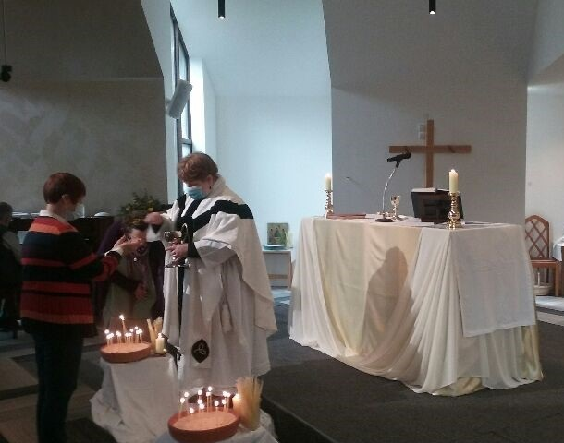

Do Justice

Do Justice Group finished a year by drawing attention to the need for the Australian people to reduce greenhouse emissions. Immediately. Over 120 churches in Australia took similar action, with The Melbourne Anglican running three pages of information and photos about The Australian Religious Response on Climate Change (ARRCC’s) Day of Action in October. The cost of the banner was paid by donation and has aroused much discussion. Ideally we would have enjoyed having a large gathering in front of the banner but we needed to follow covid regulations.

Some progress can be reported on the Yarning Circle and our hope is that aspects of the planning will move forward more quickly after discussions with the Wurundjeri Special Manager in Abbotsford.

This is the last report for Parish Matters as I am resigning from the position as leader. I would like to thank the members of the group: Keren and Linda, Kathleen, Helen, Jennifer and Jean.
Jenny Disney
Ed. Thank you Jenny for all your hard work and passion for many issues.

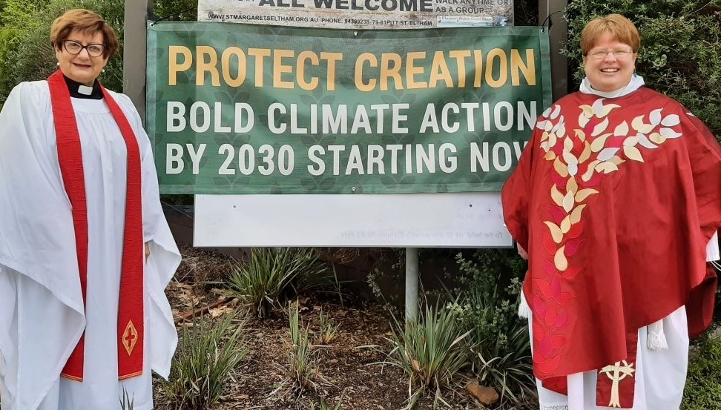

Anglicare

During the period of Covid regulations the Anglicare group has not been able to meet, so we have enjoyed meeting once more in the church hall in early November.

One aspect has not changed: the amount of knitted and sewn clothing that has been donated and passed on to Anglicare for distribution by knitters in the parish and outside the parish. We have heard that the clothing has been distributed to needy babies and families whom Anglicare is helping and has been very much appreciated. In addition, a number of people have passed on lightly used men’s and women’s clothing, and this has been quickly distributed. Thank you, too, to Jo Norman who collected and passed on over 70 balls of wool for others to knit.

As a last activity a collection on St Margaret’s day will be used for people in the Eastern Ranges where storm damage in June left many without electricity and serviceable roads for months.
Our Christmas morning tea will be held in the church hall on Tuesday 7th December from 10 am to 11.30, and many members of the Eltham AVPG will be attending the Friends of Anglicare lunch at the Hawthorn Arts Centre on Friday the 3rd December.
Jenny Disney (Leader) Jo Norman (Treasurer)

SPECIAL COLLECTION ON ST MARGARET’S DAY 2021
EASTERN STORM RESCUE AREA PROJECT
In June 2021 fierce storms caused havoc in this area (immediately adjacent to Cockatoo where Christopher is now the priest in charge.) Trees came down, cutting electricity for up to 2 months and causing damage to houses, blocked roads and created mounds of debris.
People and churches in the ranges have helped in the early stages with food parcels and donation of clothing and bed linen. However, the need is still urgent.
174 households still need help. Anglicare Victoria has now been given the task of organizing a fund raising appeal to help clean up the debris and fallen trees that is hindering the rebuilding progress. It will also help those who need assistance with purchasing white goods and larger items.
In October AnglicareVictoria sent out pamphlets to 200 Anglican parishes in Victoria and to the half dozen AVPGs, (formerly Auxiliaries) about the appeal.
St Margaret was known for helping people in trouble and giving shelter to pilgrims. We too can help these people in trouble.
To help 174 households desperately needing help. Donations of $2 or above are tax deductible. (To claim the tax deduction please put money in envelop with your name and address and AnglicareVic will give receipt Or Make deposit by credit card using we anglicarevic.org.au/donation/emergency-appeal/ and mention St Margaret’s.

ROGER RONALD KERR
24/8/43-25/10/2021)

On November 3, 2021, family, friends and parishioners gathered at St. Margaret’s Eltham and via Zoom for a service of Thanksgiving led by the Revd. Robert Street to honour Roger Kerr’s life.

Roger and his wife Rae have been parishioners here at St. Margaret’s since the 1990’s, Roger being involved in our church music, a member of the choir and Meg’s Men’s group over many years.

Roger grew up in Heidelberg with his 2 sisters and his brother (who died in the 1950’s). The family were parishioners at St. Phillip’s. He worked alongside his father at the family hardware store in Fairfield after leaving school aged 16. Roger built up a helpful, friendly rapport with his many customers and even went to night school to learn Italian so that he could help his growing number of Italian customers! Sadly this all came to an end when small, family hardware businesses could no longer compete with the growing number of corporate big box outlets! Roger then became an employee!

Roger and Rae were married in 1974 at St. Luke’s in North Fitzroy and lived in Westgarth, Kew and then Warrandyte before moving to Eltham in 1984. They had three children, Sarah, Emily and Simon and 5 dearly loved grandchildren.

The tributes made during the Thanksgiving service referred to Roger’s love of his family, his lifelong love of God, his enjoyment of music, his entertaining of young and old playing his piano accordion, his competitiveness when playing tennis, his ability to fix things, and his commitment to Freemasonry.

Some 12 years ago Roger was diagnosed with leukemia. He had a long battle fighting this illness never liking to make a fuss, Rae and his family always by his side. He lived the last 2 and ½ years at Garden Views in Lower Plenty before peacefully passing away on October 25, 2021.

Roger will be sadly missed and lovingly remembered by one and all. Now in God’s care.
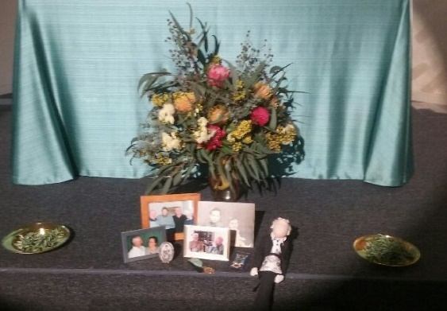

October Parish Council

The meeting opened with prayer led by Linda

Progress was reported on the Diocese’s Vision 2021 Questionnaire which was returned even though several councillors found it difficult to respond to. The response to our questionnaire on Reimagining the Future by 21 parishioners (about a quarter of the Parish) was summarised and some of the ideas proposed have already been acted on.

Others will be included in future planning particularly through the HeartEdge activity, . This is a program developed by St Martin’s in the Field (in Trafalgar Square, London).

Some of the initiatives that come from this are:
- A book group to be set up for Councillors and Parishioners and outsiders which runs for about five months and
- an Advent study over 4 weeks to be followed by 8 weeks in Lent for whole parish.
- St Margaret’s sign up to be in the HeartEdge network with St Georges Ivanhoe being the hub to support us and other parishes.

We are hoping that everyone will make an effort to participate in these activities.
Synod was quite challenging as an online meeting with technical glitches from time to time. (See Felicity’s report and refer to TMA for report,
At Parish Council a motion of thanks to Felicity Wiltshire and Sally Petty for being Parish reps for the last three years, was passed with acclamation.

Progress towards the Yarning Circle was reported with a meeting with contact for Wurundjeri people and a plan to generate primary school interest next year.

It was agreed for the PCT seminar on dementia would be delivered on Nov 7th .

Dates for submission and release of items for Parish Matters to go in pew sheet, with invitation to submit two weeks before PM due out.

Important visits were noted: Archbishop coming on 14th November St Margaret’s Day and
Bishop Kate coming 24th December Christmas Eve
After discussing progress on compliance and governance issues the meeting concluded with Compline led by Keren.
Reporting for PC Harry W

Editor This edition Sally
Pics. Harry, Mary.
Next ed. Due out 12/12/21
Copy due 7/12

