No 1 2021 March Edition 16 March 2021





Celebrates parish life and reports important items from the most recent Parish Council meeting
Find us on the web at www.stmargaretseltham.org.au/ Facebook at www.facebook.com/stmargaretseltham

O God, our Redeemer,
in our weakness we have failed
to be your messengers of forgiveness and hope:
renew us by your Holy Spirit,
that we may follow your commands
and proclaim your reign of love;
through Jesus Christ our Lord,
who lives and reigns with you and the Holy Spirit,
one God, now and for ever. Amen.
In This Issue
MAT Seminars
Ring the Bells for Change
Parish Council Summary
Pub Lunch Success
Men’s Breakfast First
Pastoral Care
Anglicare and Do Justice
Lenten Studies
Cameras at Work
Christmas Wayfarers

We’re Back and Welcome to You All

It’s 13 months since our last edition The fortnightly e-Musings kept us connected in the meantime. Enjoy the good news as we emerge out of COVID!

Upcoming Must Attend Seminars

We all have a strong interest in our environment and climate. Think about nature, how much you feel dependent on home services, water, power and ‘phones etc and how much we depend on the weather local, national and beyond. Even if you don’t believe in global warming, or don’t think you need to because you’ll pass on before a catastrophe happens, I ask you to think about the Precautionary Principle, we all use it in your daily living. If there is something we don’t understand and are uncertain how it may affect us, we try and reduce its impact on ourselves if it’s not too hard to do so. In economic terms you do us much as you can if it doesn’t cost (technical jargon is up to breakeven).
So we are asking that you do at least as much as you can. Not nothing !
The three seminars have the detailed advertisement later on.
You will recall that the Mission Action Team (MAT) discerned that we should focus our Pathway(s) on people who are lifting their heads up to think about later life. May be retirement but earlier too. The first Path that MAT have come up with is the evidence is that the global and local environment is important to many. From the beginning we need to deliver ACTION. Action in the perspective of our faith and within our ability to make a difference You may not have thought about it seriously, but even with the new LED lights that save a huge amount of power (80% perhaps), still when you have half those lights on that you usually have, the electricity used is halved. Just a small illustration that as concerned people we can make a difference in the way we behave.
Seminar 1 Faith and Environment: What Grounds Us?
Saturday 27 March, 2.30 – 4.15, with afternoon tea. Presenters include
- Professor Mike Clark, Ecologist and Evolutionary Biologist, La Trobe University,

.
- Sr Anne Boyd, Leader, Brigidine Community,
- a speaker from Australian Religious Response to Climate Change

And on the 4th Saturday of the next two months

Seminar 2 Climate in Crisis: What Can Be Done? Saturday 24 April

Seminar 3 Action and Advocacy – What Can We Do? Saturday 22 May

After well over two years (slowed by COVID) the Mission Action Team has made remarkable progress recently. The seminars are driven by SAGE (St Margaret’s Action Group on Environment). In a nutshell, it with other like-minded community groups, aims to provide a place of belonging to people in Nillumbik and surrounds who are interested in caring for our environment, local and global. The details of how this can be achieved have been mapped out and will appear in more detail in a later edition.
Thanks to the MATeam John H, Mitzi, Sandra B-H, Mandy, Harry and our chair Keren
Please give us your support by attending!!
Harry Watson

Ring the Bells

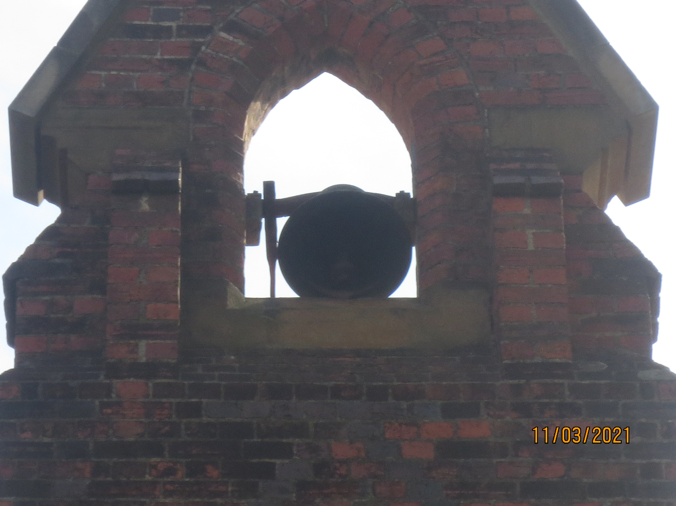
Consistent with the push for environment action we participated in the global Ring the Bells Action for Climate Change. The bell ringer, Roger, the bell swinging and those involved can be seen in action in these pictures.

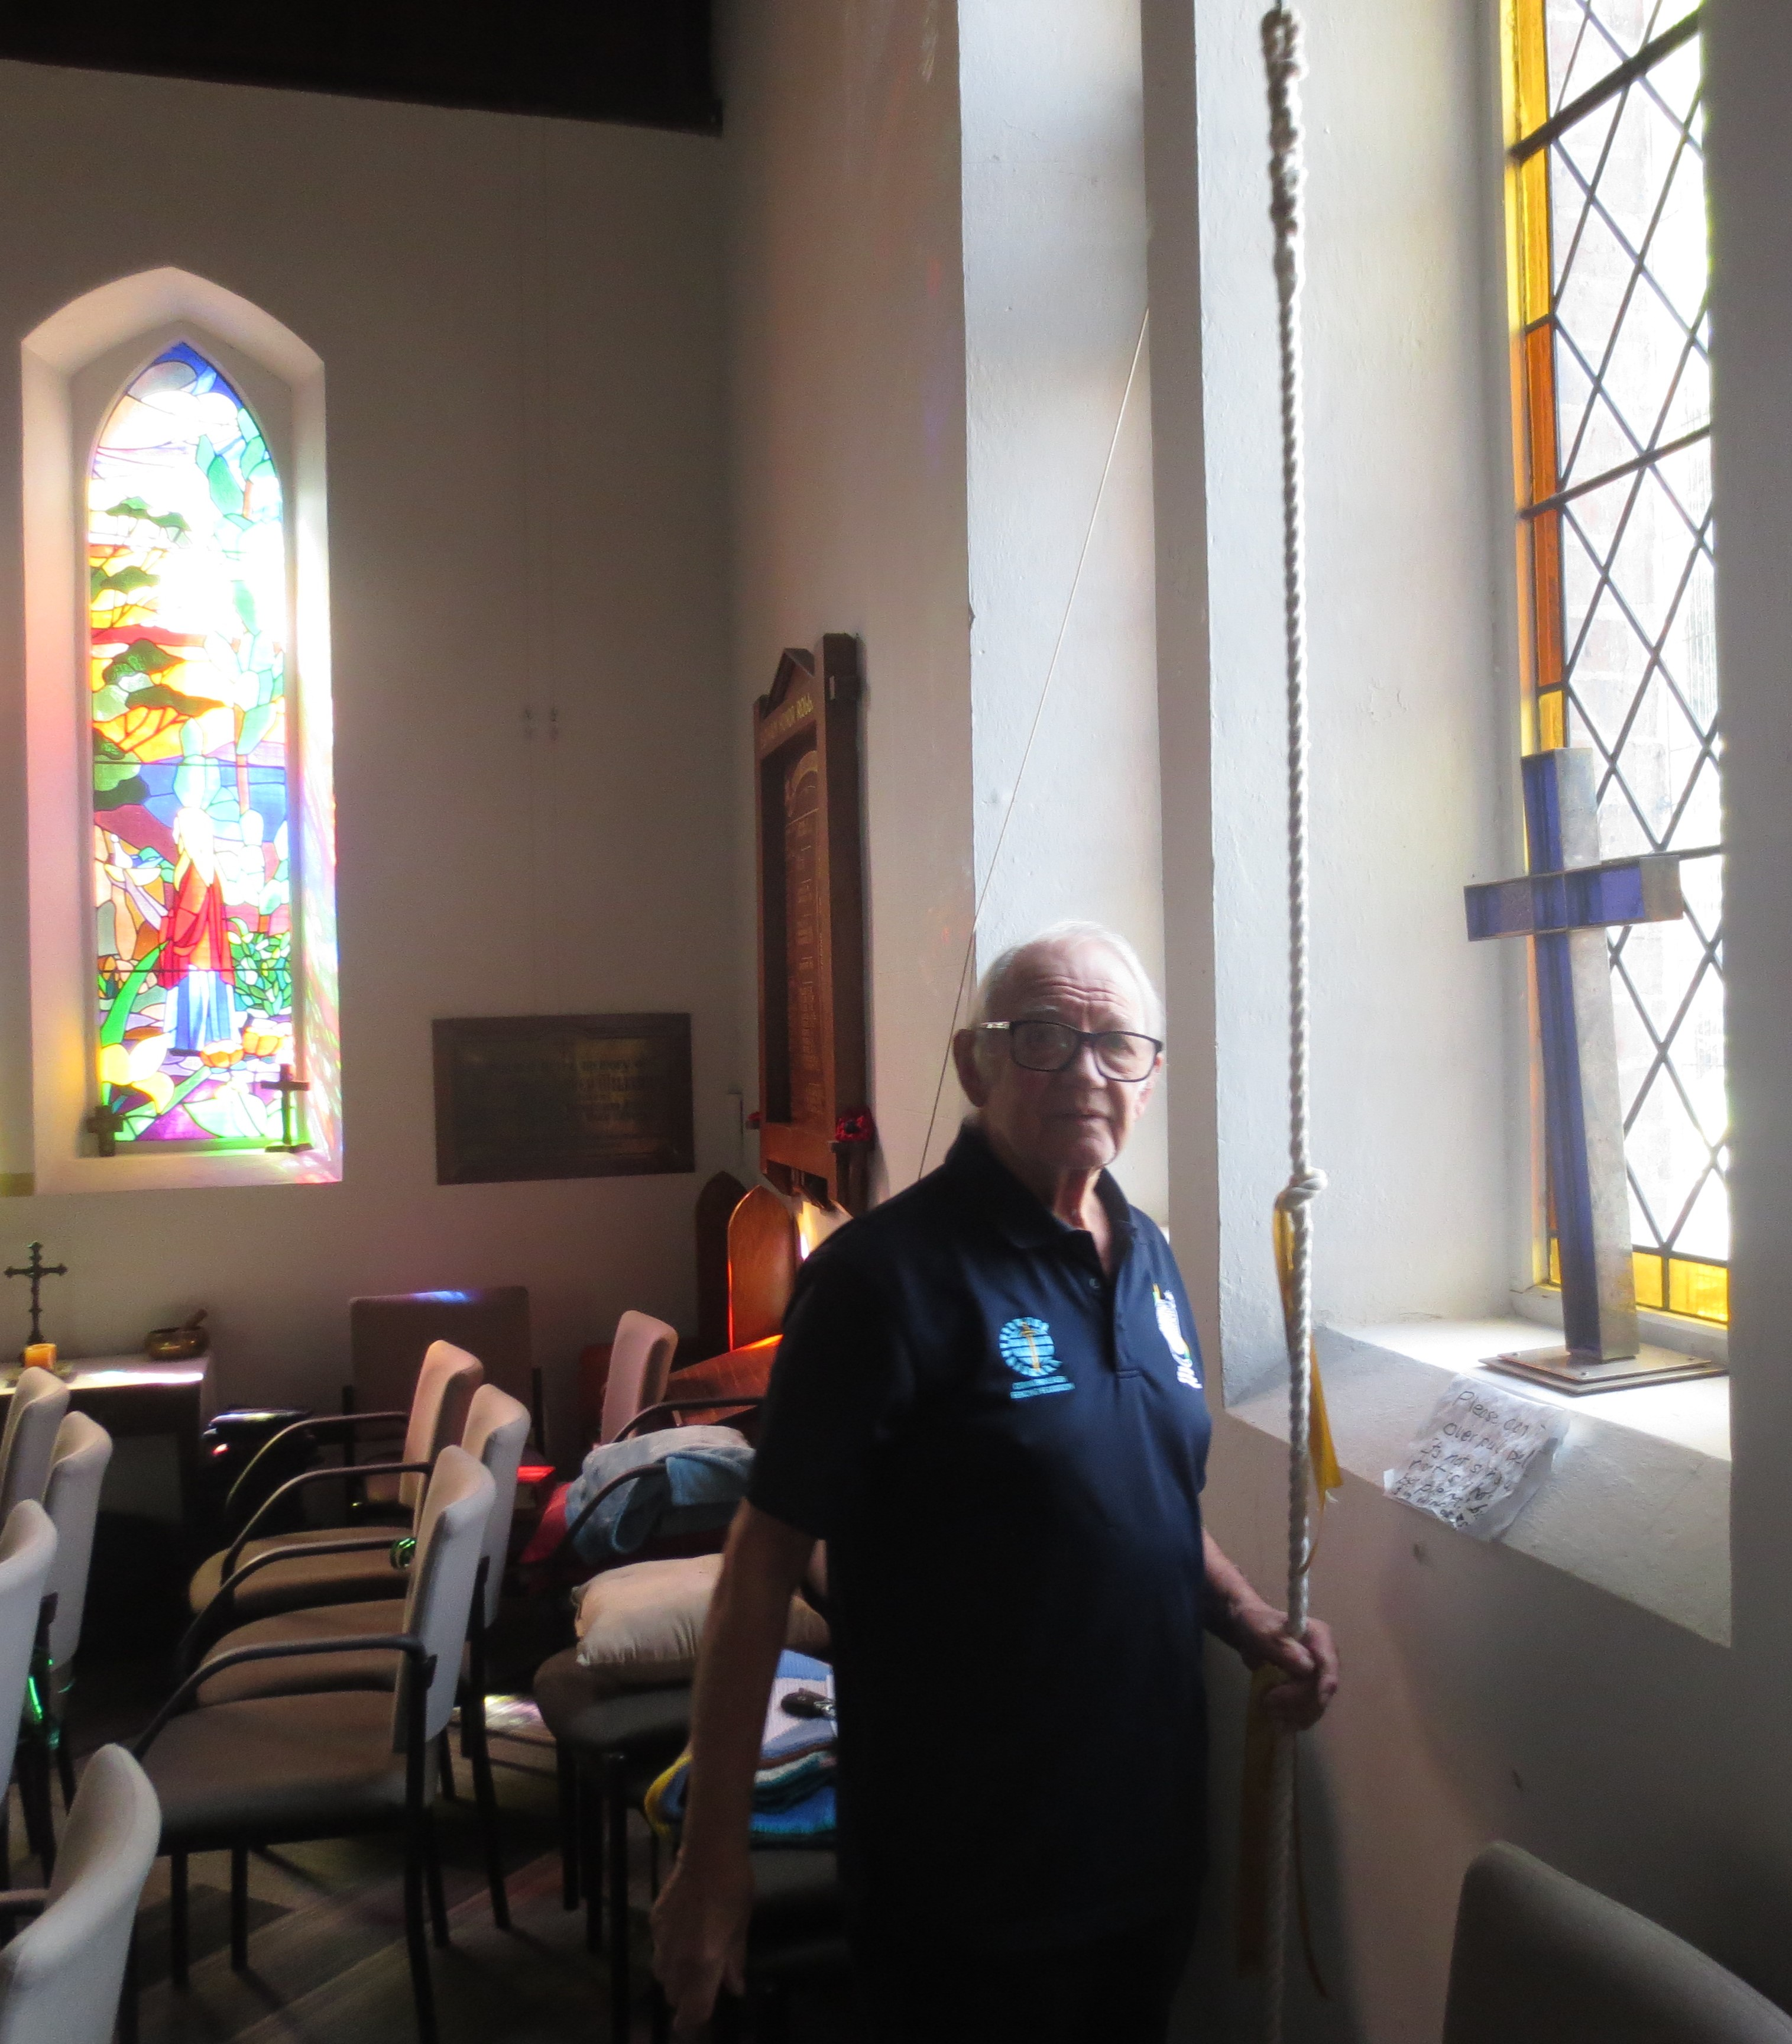
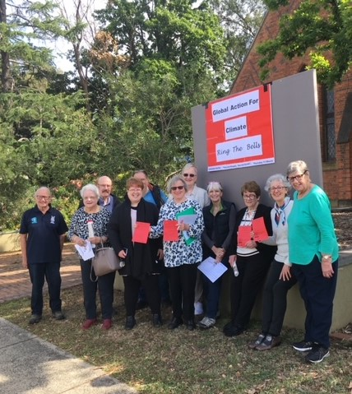:

Parish Council Highlights

Event Planning Forms were received and approved as follows:
- Do Justice Committee for Ring the Bells on Thursday 11 March @ 11.00am sounding the alarm for climate emergency and the environment. (See photos later)
- Anglicare for a Blumes Fashion Parade on April 13.
Vicar’s report
- advised of new appointments for Denise Nicholls, Banyule parish and Archdeacon, Tim Johnstone from Diamond Creek.
- Presented further information and document on child safety provisions.
- Keren’s leave (mid June to mid Sept.) which includes annual leave, long service leave, retreat and clergy conference.
- Our Locum will be The Revd Linda Fiske currently Assoc. Priest East Ivanhoe and previously school chaplain at Christ Church Grammar School.
- Victorian Anglicans together met recently, further information next edition.
- Keren has been appointed to the National Liturgical Committee
Where we are at on:
- Music Program - progressing, student has accepted scholarship offer.
- HeartEdge: six seminars being jointly run by the Dioceses of Brisbane and Melbourne.
- Pathways: we’re in the third year of the Pathways program. The MAT is organising a series of three sessions around environment action
- Easter planning is underway.
- The World Day of Prayer is being hosted by the UCA Eltham-Montmorency, but we’re providing the venue on Friday 5th March at 10am.
- We read two chapters from a book by Samuel Wells, with a view to incorporating ideas into our Vision Plan.
- Treasurers Report presented:
We are now reviewing how to incorporate a surplus into the Budget for the next 3 years.

Sally Petty

Popular Pub Lunch Back

It was a joy to attend ‘Pub Lunch’ at Eltham hotel on 7th February with members of our Church family. Thirty-one Saint Margaret’s parishioners gathered, the largest group of attendees ever. At the March event we were thirty.

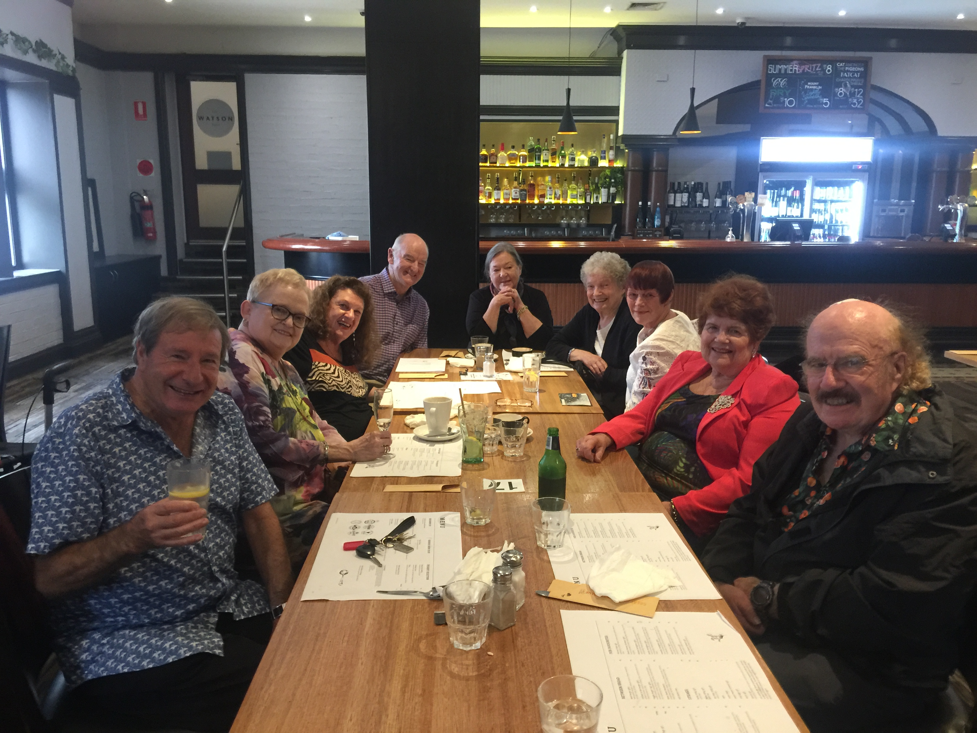

I had forgotten the importance of being with and seeing our beloved friends and sharing stories sprinkled with much laugher and cheer. I am humbled at the care and support l have received from my church family, especially in times of need.
Everyone is cordially invited to Pub Lunch, especially those who may be new to St. Margaret’s. We would very much like get to know you and to share your lives, and thank our Lord for all the gifts he brings. The gift of love, and the gift of friendship. These are two of the most important gifts of life.
Pub lunch is on the 1st Sunday (except Easter Day) of each month, commencing at noon.
Please include these dates in your diary for 2021:
April 11th September 5th
May 2nd October 3rd
June 6th November 7th July 4th December 5th
August 1st
Love and blessings Jenny Gillett

Men’s Breakfast First Up

From March last year Men’s Breakfast was on-line including the additional third Saturday Men’s Chat. But on the first Saturday of this year we were sharing a meal around a table again including two or three people who no-longer make it to regular services. This was outdoors as you can see as we cooked everything on the barbeque, avoiding the use of the Hall kitchen which is off limits because of our COVID safe policy.

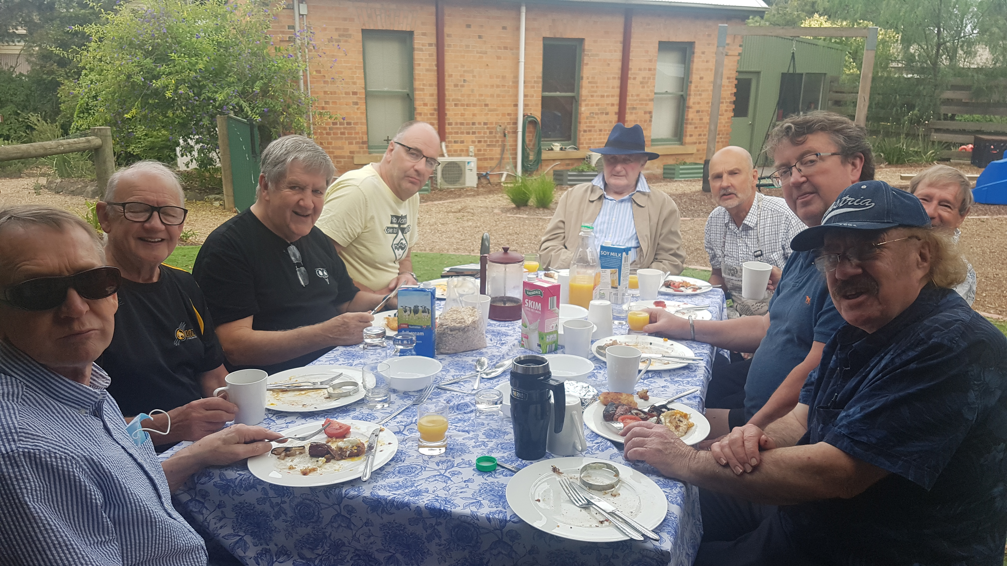

I think we were the first group to share a meal. We were pleased to welcome new members Roger A and Rob M (not seen as he was the photographer). For this and the following months’ meals there was extended discussion about our first nation people who lived in this region although it took us until March when we formally noted the acknowledgement as required of all small groups. Also in March, John F re-joined us. We had not seen him for a year.
The Next Men’s Breakfast is on Holy Saturday April 3. After some discussion with our clergy members it was agreed we would partake of a very humble meal Sausages, bacon and eggs are definitely off. So if you have vegetarian leanings now is the time to come along and join in: serious conversation and prayer with humble food.
Harry

Reports – Pastoral Care Team

At the first meeting of the Team in February we welcomed new member Sheila Cheary. She comes with a relevant skill set including a lot of professional experience with dementia care.
At our first face to face meeting for a while, discussion indicated that we were struggling to give care to the nearly 40 people on the contacts list. As it had been a challenge to manage this even when visiting was restricted by COVID rules. Thus it was decided to focus on the really needy, nearly 20 people who need visiting, to continue telephone contacts with a several others and have a new category called informal. In March this strategy was even put under pressure as Revd Robert Street and MaryAnn Wilkie tendered their resignations. Their contributions will be sorely missed as they have both be with the team for over ten years and their abilities to be gentle, compassionate listeners and much more will be irreplaceable. We plan a farewell lunch to say thank you. If you are moved to add your thanks in some way, perhaps in writing or by other means please send it to Jen in the office, or Keren or myself. Christopher will be leading the worship services on the second Wednesday of the month at St Vincent’s aged care with Robert as back up.
Harry

Reports – Anglicare and Do Justice

AVPG
Main Points from meeting.
Plans underway for showing of Blumes Fashions on 13th April Please watch out for flyer on this and support this fund raiser if you can.
Noted that Brazier for the fire pit has been delivered to Church and looking forward to landscape designers drawings This will take place on a Saturday in March..
Next meeting will be held at home of Bev Thomson
Do Justice Group
No formal meeting this month. It was noted that all church groups have agreed to acknowledge the land where we meet as the traditional land of the Wurundjeri and pay our respects to the elders past, present and emerging.
From reports to Council

Missing out on Lenten studies

The series of videos and follow up questions produced by Trinity College Brisbane are top class, not just because Keren trained there, but because of the incisive presentations by quality leaders that
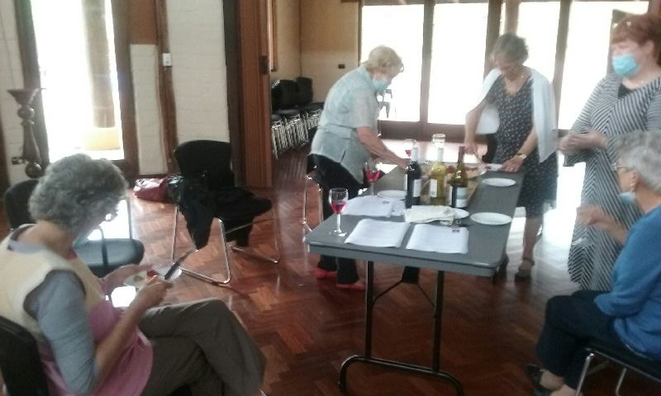have caused us to think seriously about Jesus Christ and who he was and is to us. Also you are missing out on other good things too. Thanks to Keren 4pm Sundays and Christopher 7.30 Tuesdays for leading these so inspiringly.

Next Weekend Please Come



Two Cameras at Work with ATEM

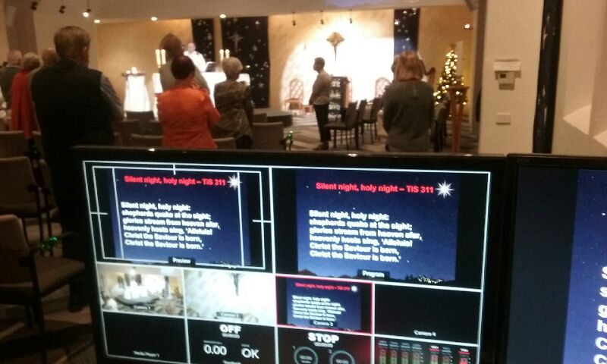Our acquisition of two Sony cameras and an ATEM mixer are allowing us, with extra light from adjustable (even colour) spot lights hidden in the beams, to take Zoom connectivity of the 10 am services and other events to those unable to travel to church. At the moment there are about ten people taking advantage of the opportunity. Given time Keren is hopeful that we can ‘live stream’ to Youtube. Already if you go to the St Margaret’s Youtube site you will find many past services and last Saturday’s brilliant look at Mark’s gospel if you missed it!! Please spend some time there.

Christmas Wayfarers

In the foyer of St Margaret’s when the travellers from afar arrived. Did you see it? Here’s how it came about. I was critical of the lack of eyes.
Read David’s response in this poem about how he and Mitzi embellished the images that Keren procured.

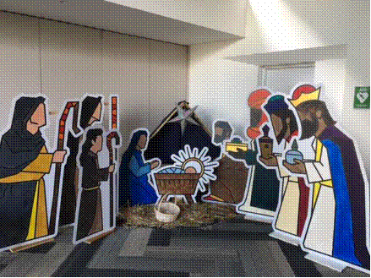

The artist
Sleep baby child, I have work to do
Ere morning comes I must finish my work
Cross the tees and dot in the eyes
The last pieces in my graphic design
New and bold, clean of line.
An angel came and said,
Leave the eyes of all but mine,
For I see all that is, and all divine.

The Vicar
Sleep baby cat, I have work to do.
Ere morning comes I must find,
Christmas figures bold and new,
Yet to our old tale be true.
An angel came and said
See here a design
New and bold, clean of line.

The parishioner
A practical man, ideas aplenty,
To rig up a stand for figures
Time and tide but against
Came down on Christmas Eve,
to see figures bare and white,
A modern design,
New and bold clean of line
An angel came and said,
Fear not, for I see,
An eye for colour, a mind for design

The painter
Boxes of colours bright and sombre,
Appear on kitchen tables.
figures laid out bare and white,
Fill in the lines, colours flat but vivid, she said
Texture in the shepherd’s robes
Clan colours in Staff and headband,
Plain but clean, rustic homespun for shepherd.
Figures take shape and colour
New and bold, vibrant of hue
An angel came and said,
Leave all the eyes but mine

The angel
Figures resplendent came to church
Set up in crib, hay and sack, traditional
New and bold, clean of line yet vibrant and true
An angel came and said
For I see all that is and child divine
You must now see with your own eyes
Shepherd and sheep, mother and child,
Patient father, restive donkey and magi afar
All come to the see the newborn King,
In Swaddling clothes and wicker manger laid
Come and see with your own eyes
David Tuke

Ed this edition Harry Watson
Pictures by Jenny Gillett/David Tuke, Rob McKenzie and Harry

esp

