Sermon
Pentecost VIII
4/8/19

Eltham

Planned Giving I 2019

Readings
Hosea 11:1-11
Colossian 3:1-11
Luke 12:13-21 (rich fool)

Narrative re giving: what are you doing with what you have? You can’t take it with you. Recognising our possessions are not our own, but interconnected – life itself is God’s gracious gift. Time to reflect on our giving:

+FSHS

Recently when I was home with the flu and feeling like death warmed up I lay on the couch watching daytime TV. I don’t often watch commercial channels (prefer the ABC), but flicking through I was struck by the fact that every second ad during daytime TV seems to be for life insurance. Or funeral insurance. Or car and home insurance. Insurance for your bicycle, for your jewelry, for the jewelry you wear when you go out, for stuff in your car should it be stolen. Insurance and the need to have it seems almost ubiquitous… Or at least, that’s what insurance companies want us to think.

The thing is, we hear today’s gospel reading and puzzle: what he did in storing up the excess of his harvest, building bigger barns to hold it as an insurance policy for the future, setting himself up nicely for a comfortable retirement – this is what our society has geared us for. We have compulsory superannuation, many people invest in property or shares, and much is made of self-funded retirees who are not drawing a government pension. So we look at what this guy did in Jesus’ story, and hear Jesus call him a fool, and go, whaaaaat? Because what he did sounds sensible to us. And if we want biblical evidence for the wisdom of stewarding our resources to see us through times of trial, there’s the story of Joseph, who at God’s revelation helped Egypt to save 7 years’ worth of excess to last through 7 years of famine. So what’s really going on here in this story?

Listen to the fellow’s inner dialogue: “"What should I do, for I have no place to store my crops?' 18 "I will do this: I will pull down my barns and build larger ones, and there I will store all my grain and my goods. 19 And I will say to my soul, Soul, you have ample goods laid up for many years; relax, eat, drink, be merry.'” What do you notice in this inner conversation? It’s all about “I”. He didn’t think, “I know, I’ll give the excess to the temple to be distributed to the poor”, nor did he turn to prayer offering thanks to God asking God’s discernment for what he should do with the excess. Instead he came up with a strategy which was all about himself – not even about leaving wealth to his children or family. In other words, greed over what he had occluded any sense of interconnectedness with others, and with God. He has forgotten that all that he has, all that he is, is because of God’s gracious gift – and that gift of life is also in God’s hands, to be granted or called to account. He has made the mistake of thinking huge barns full of grain will give him security for life, and has tied his sense of security and selfhood to having a great deal of goods. But the quantity of what we have and how secure it is doesn’t define who we are, and nor does it give us security – much as the insurance companies would wish us to believe otherwise. Fear is often the flip side of greed; fear of not having enough, of not being able to provide for oneself or one’s family, drives greed. But greed is an empty idol with a bottomless black maw which will never be satisfied.

By contrast, Jesus talks about those who are “rich towards God”. I don’t hear him condemning in this those who are wise stewards of what God has given – on the contrary. The height of wisdom in managing what God has given us is to recognize: a) all we have comes from God, not from our own effort; b) it’s not really ours in an empirical sense, but we are stewards who will be called to give an account; c) in all things, that our hearts first be open to God, our decisions directed by our connection and relationship with God, and mindful of the others around us with whom we are in community. That’s not just those in need or the poor and hungry. The guy in the story saw the excess as his own. But what of the numerous farm workers who would have been doing the hard physical labour for him? Possibly slaves whose exploitation meant they wouldn’t benefit from the bounty and who, on his death would face an uncertain future? What about merchants and bankers who would have been involved in his trade dealings? And the small business people in the marketplace whose goods and services he could purchase by spreading his wealth? None of these people are considered – not in the sense of charity, or in the sense of economics. Love of neighbor is integrally connected with love of God. Love of God drives us to connection with our neighbor, and love of neighbor draws us back to God. How we steward our resources is just one aspect of how this web of relationship is lived out. If we offer all that we are to God – being “rich towards God” – we have nothing to fear.

And that is the starting point of stewardship. Jesus is prompted to tell this story because two brothers ask him to arbitrate between them in the matter of a probate dispute. It’s interesting, isn’t it, how many fights, relationship breakdowns, and so on, are centred around money/wealth. Jesus changes the whole tenor and direction by saying to the warring brothers, you guys have this wrong. God’s not interested in who has more money, but in whether your hearts are turned to God, and find in God the richest treasure there is. Because everything flows from this.

Paul puts it slightly differently, but meaning the same, in the reading we had from Colossians. “Set your minds on things that are above, not on things that are on earth, 3 for you have died, and your life is hidden with Christ in God.” He exhorts them to put to death the things that bring death: “fornication, impurity, passion, evil desire, and greed (which is idolatry),” and to get rid of “anger, wrath, malice, slander, and abusive language from your mouth” and not to lie to one another. He encourages them to be clothed in the “new self”, being renewed in the image of its creator, so that there are no foolish divisions between people for Christ is all and in all. That’s breathtaking in its sweep! And it is from that “new self” found in Christ, whose heart was always turned to God that our call to wise stewardship comes, the starting point.

August is Planned Giving month when we reflect on these things: that all that we are and have comes from God and returns to God, passing through our hands not to be grasped by distributed to the benefit of all. In the coming weeks we’ll be encouraged to make a pledge for the work of St Margaret’s in the next year – especially thinking about some of the ministry actions in the Vision Plan 2020. We’ll be celebrating and looking forward in hope at the High Tea on 31st August, and will bless the pledges we have on 1st September.

For today, may we hear again the call to radical trust in God, and take time this week to touch into the reminder that we are completely dependent on God, that all that we are and have comes from God, an invitation to joyful trust.

St Patrick’s Breastplate

The Lord be with you.

And also with you.

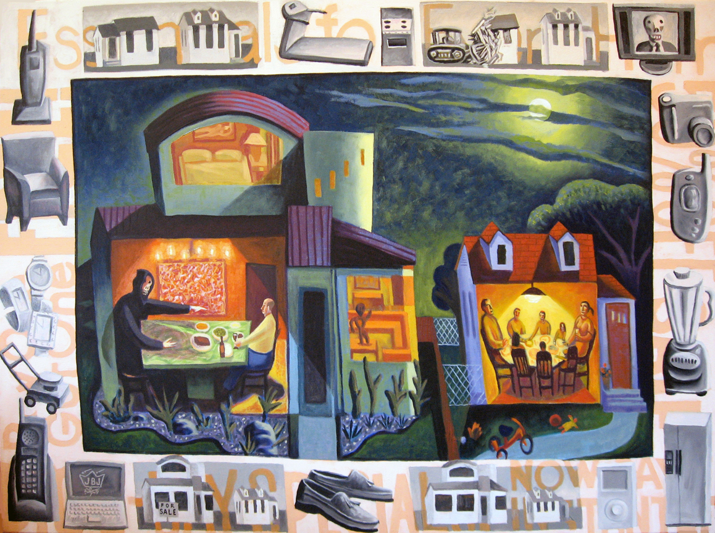

James B Janknegt “Rich Fool”

Christ be with me, Christ within me,

Christ behind me, Christ before me,

Christ beside me, Christ to win me,

Christ to comfort and restore me.

Christ beneath me, Christ above me,

Christ in quiet, Christ in danger,

Christ in hearts of all that love me,

Christ in mouth of friend and stranger.

I bind unto myself the name,

the strong name of the Trinity

by invocation of the same,

the Three in One and One in Three,

of whom all nature has creation,

eternal Father, Spirit, Word.

Praise to the Lord of my salvation;

salvation is of Christ the Lord!

