Sermon
Epiphany III
26/1/20

Eltham

Readings
Isaiah 9:1-4
1 Cor 1:10-18
Gospel: Matthew 4:12-25

+FSHS

At the beginning of the week I was in Sydney for a concert and staying on William St, close to Kings Cross. Anyone who’s ever been to William St, or who has seen news reports or other footage in movies and tv shows will know the iconic Coca Cola sign blinking away over the underpass at the top of the hill since the 1960s:

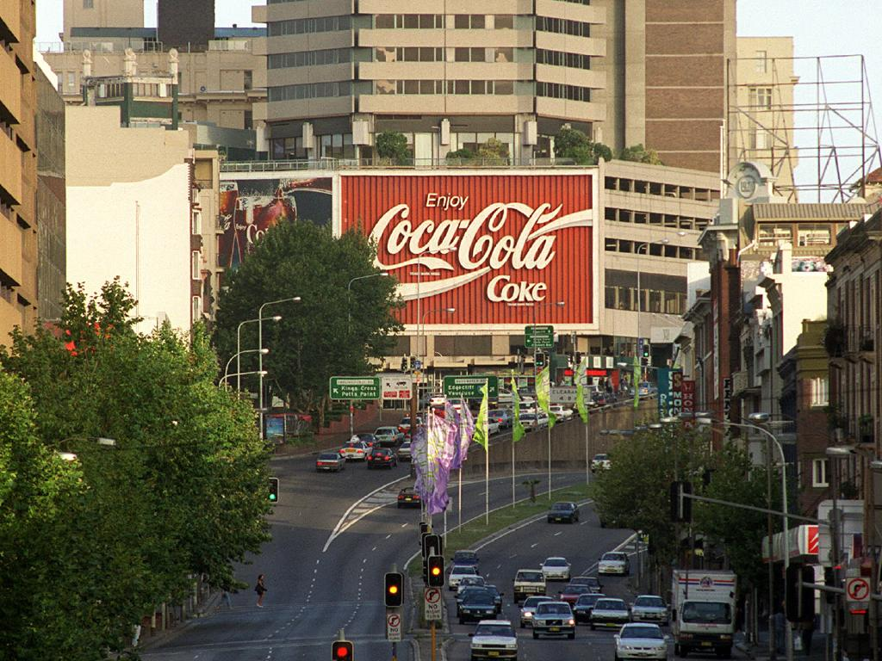 Or, lit up in all its glory:

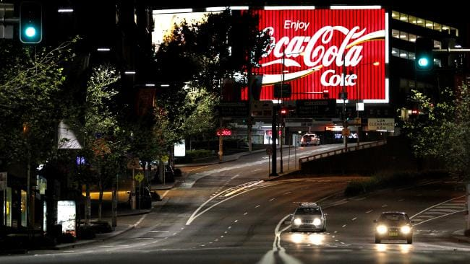

It’s a light proclaiming boldly the world-domination of a multinational company. And we know that behind the glowing neon tubes is a story of exploitation, destruction of the environment, and addiction to sugar and caffeine which enslaves many – especially in developing nations where fresh clean water is in short supply. It’s a light which purports to signify “good news”, but which is selling an illusion.

Light is something we take for granted. There’s no need for any of us to fear darkness, because at the flick of a switch we can activate the electricity in the grid to turn on the light. And if we don’t have electricity (which, oh my goodness, is the end of the world because we then don’t have access to the www), then there’s gas lamps, candles, matches, and at a pinch we can set a fire without too much trouble.

Light for ancient people was precious; Fire in particular was seen as the gift of the gods. And in Aboriginal culture, fire and light were of central cultural, religious and ritual importance, the burning of the bush a sacred task entrusted to each new generation to preserve the land. The light of the sun and moon and stars, these were valued. Fire light, candle light, and oil lamps required use of precious, expensive fuels. The peoples of OT and Jesus’ times couldn’t just flick on a light and stay up all night reading. Darkness defined activity; many went to bed and rose with the sun. The darkness was a time for fear and shadows, when non-domesticated creatures went hunting. Darkness was a time of dissembling, hiding away the evil done, a risky time.

Isaiah in our first reading characterizes the people’s condition as like being in darkness and yearning to see the light. The land of Naphtali and Zebulun had been vassal states to Assyria long before the kingdom of Israel fell; they’d been in a situation of colonization, of political dominance by a foreign power. Making it a land of brutality, a land of poverty and hunger, a land without hope. A conquered people, subject to the whims and demands of overlords, powerless. Security and safety stripped away. Every asset will be usurped by the conquerors. Every child born can be taken by the more powerful into slavery. Every field planted with crops can be harvested by the mighty. Every hope for the future is stolen by masters who have the final say. This is the land of deep darkness, a darkness emotional and spiritual as well as political; a darkness in which chaos reigned.

Into this darkness the promise of God’s light breaks through. Matthew in the gospel reading claims Jesus’ movements as the fulfillment of Isaiah’s prophecy: the true light shining in the darkness to illumine God’s people. And of course that’s what we celebrate in Epiphany season: the Christ-light come into the world to bring God’s light and life. And starting his ministry in Galilee, Jesus proclaims a message: “Repent, for the kingdom of heaven is come near.” This is the new light, the good news: a kingdom which is not about exploitation, but in the light of which justice is done, and the world is made new.

We often think of the call to repent as personal and individual: to repent of our sins. One of the promises we make in baptism (and which Emerson’s godparents will make on his behalf today). In doing so, we commit ourselves to a life of repentance: not of breast-beating because we’re miserable sinner-worms, but in the sense of turning again. Of turning back, that each time we fail to live God’s way, we get up and turn back to God and keep walking. When we make that promise we realize that we are not going to get things right all of the time, and therefore need God’s help to live God’s way.

But the call to repent on Jesus’ lips as he goes around Galilee is more than just about personal sinfulness. It’s more like a clarion call to open our eyes, to see the new reality breaking in – the light of the kingdom of heaven. Kingdom of heaven, not kingdom of God here is important: it’s a way of being, a way of living, living with the values of heaven instead of the values of the world. That’s also something we promise in baptism: to reject selfish living and all that is false and unjust. In rejecting these things, we are declaring our intention to live with an awareness of our interdependence with the people and natural environment around us; to live by doing justice and loving mercy in how we deal with others; to love God with our whole heart, with all that we are; and to love our neighbours as ourselves. This kingdom heaven is about freedom for all who can see it. It is light and peace and truth. It is a reality marked by the forgiveness of sins, the resurrection of the dead, the new creation of all that is dead and fallen, and the reconciliation of all things to God. And it stands in stark contrast – like the contrast between light and dark – with the kingdoms of this world and their values.

Many of us this January have been walking in darkness, or feeling like there’s a great deal of darkness around us: the horror and tragedy of the bushfires; the wars and rumours of wars in Iran, Lebanon, Brazil; the intractable attitudes of politicians and world leaders towards the changing climate – and worse still the knowledge that behind those attitudes is the reality that most western democracies are really oligarchies dominated by the values of mining companies and billionaires who have made their fortune by exploiting and enslaving others. I am sure I don’t need to keep narrating the litany of darkness; we all know it. And on this Australia Day or Invasion Day, the truth that our national flourishing has come at the expense of the original inhabitants of this land, and we as a nation still haven’t properly addressed, and our leaders refuse to address, the issue of the sovereignty of Aboriginal people and the injustice done to them. And if that wasn’t enough, we know it also on a personal scale: the darkness of the struggle with mental illness, the darkness of loss and death, the darkness of our own hard hearts and unrepentant attitudes of prejudice to others; the darkness that leads us to snap or deride, to persecute and rail in anger against others who don’t deserve that treatment, to complain and whinge.

Into all this darkness the Christ-light comes and calls us to repentance, to see the reality of the realm of heaven around us, and to turn from our ways and instead to live the ways of justice and peace. In baptism we are made one with the Christ-light, and we share Jesus’ calling to shine that light at all times and in all ways in our world, in our own lives, in the lives of those around us. In this heavenly realm, everything we do counts: the kind word, the gift given, the quiet presence, the help we give to those who need it, encouragement offered to lift the spirit. It’s not about dramatic gestures, but a pattern of living which is oriented towards choices for justice, and towards living peaceably, being peacemakers. This is light which shines in the darkness. And as in the Isaiah reading, it’s not light which we generate, but the Christ-light shining in us and through us, his heart beating with ours. It’s in the ordinary things of life that God is revealed to us, and in which we experience God’s presence if we are able to open our eyes to it, to see the reality of heaven’s realm. May we have the grace this week to participate in the realm of heaven and to live boldly in its light, spreading good news.

The Lord be with you.

And also with you.

