Sermon
Christ the King
24/11/19

Eltham

Readings
Jeremiah 23:1-6
Colossians 1:11-20
Luke 23:33-43

+FSHS

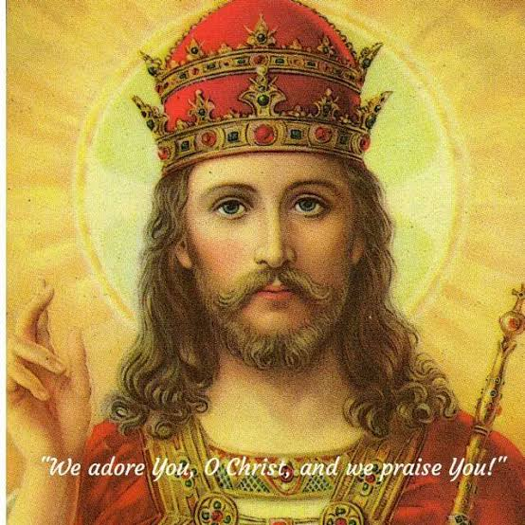.

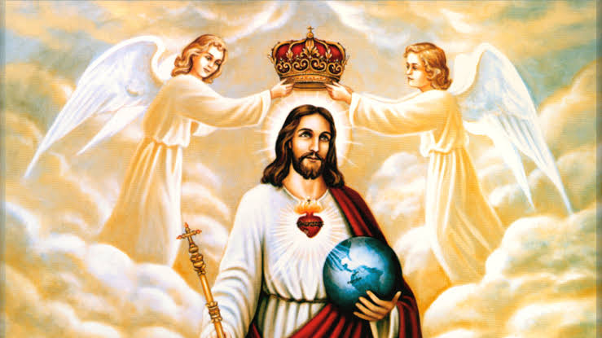

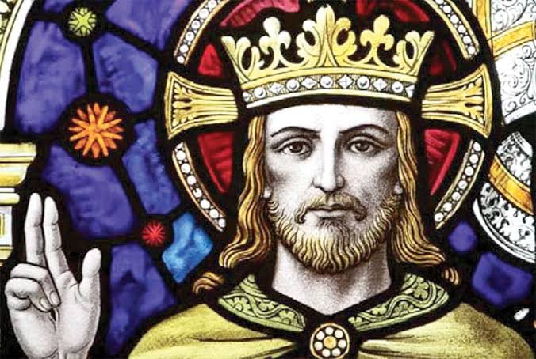

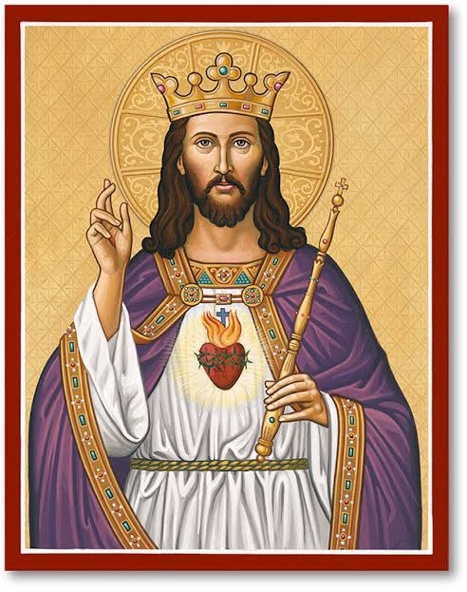

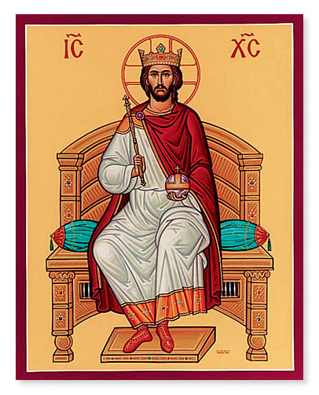

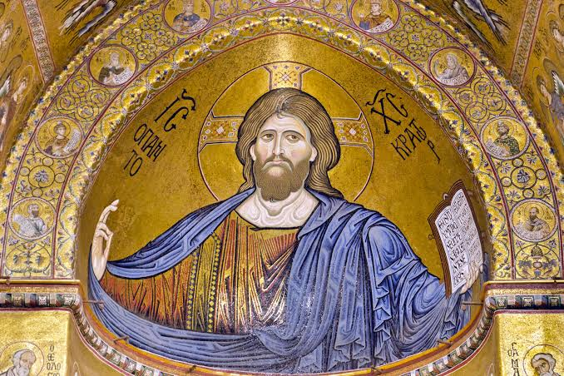

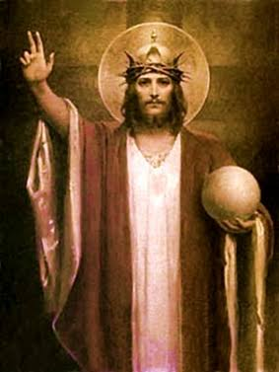

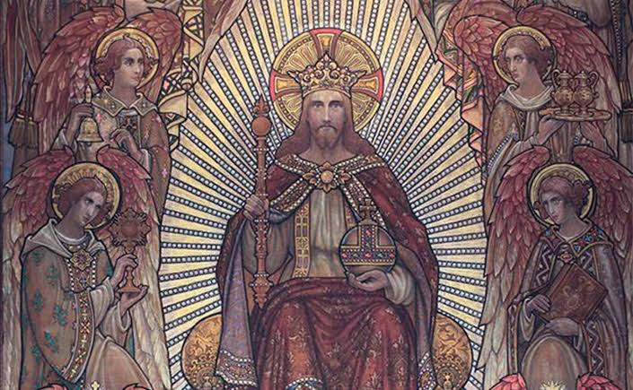

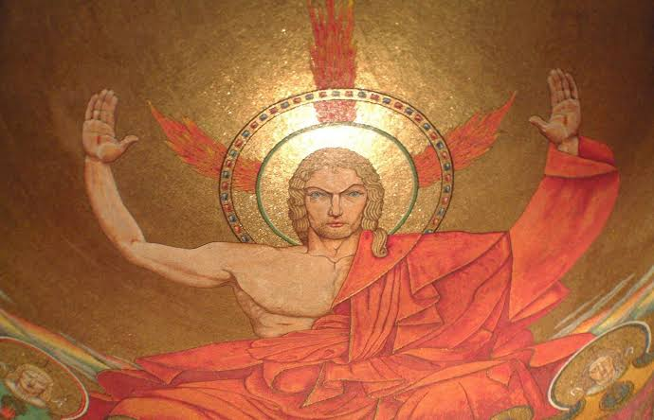

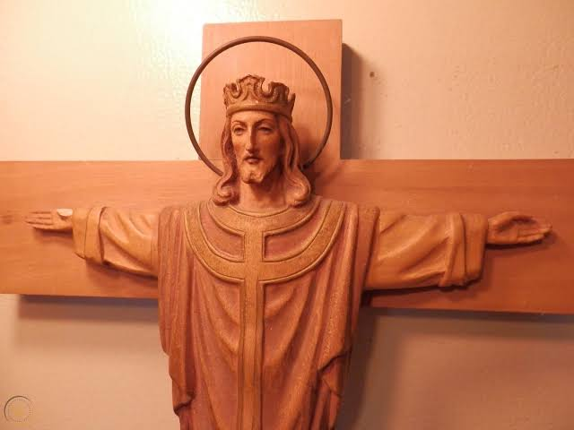

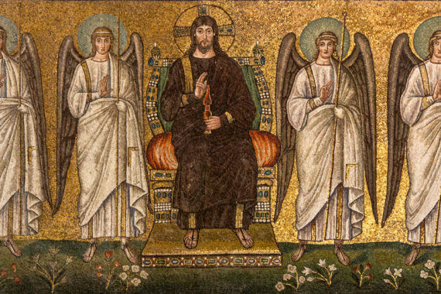

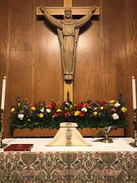

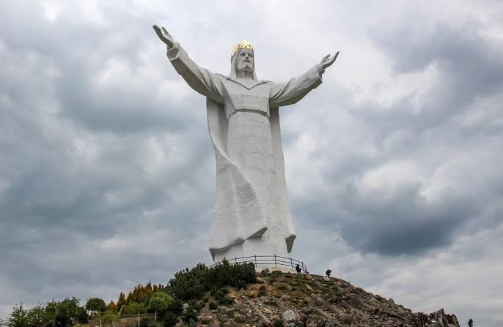

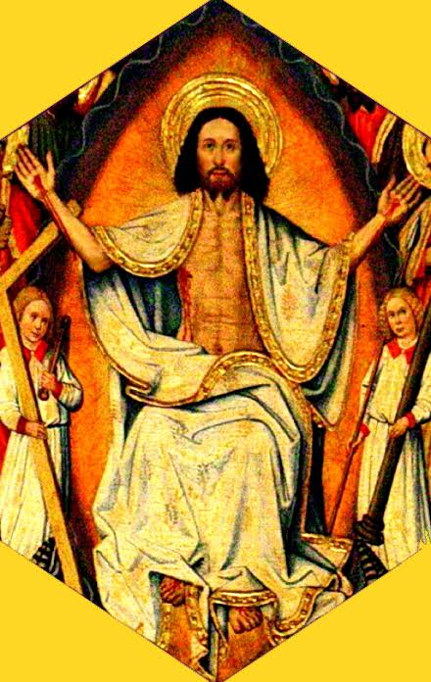

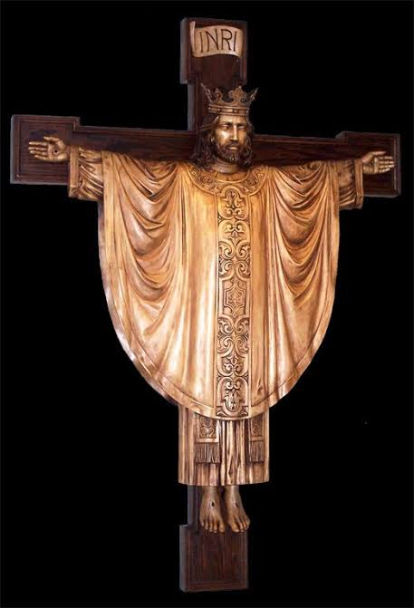

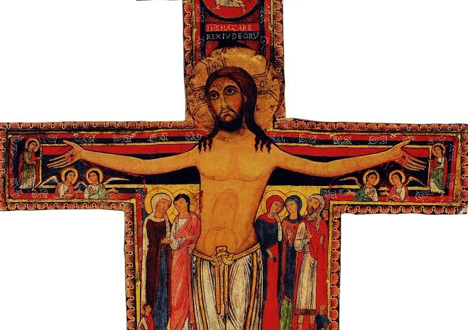

All these images of Christ the King portray a particular understanding of power and how it’s wielded. What kind of things do they say to us about Jesus, who he is, what he did, and what we’re supposed to do in response to him?

Models of kingship in the readings: in the first reading the image of the shepherd of God’s people, bringing justice and righteousness in his kingly rule. This we think refers to Zerubbabel, one of the descendents of King David who after the exile of the Jewish people in Babylon, was hoping to become king. It never happened. The prophecy is usually taken by Christian commentators to refer to Jesus – or at least suggest something to us about the difference with which he reigns.

In the reading from Colossians, we hear a majestic sweep: Christ is the firstborn of creation, the image of the invisible God walking among us, the head of the church, through whom all things were created. This is kingship of a different order: not the wielding of power over, but the sustaining, generating, connecting power of God’s life-force energy embodied in human flesh. And with it we’re a little closer to what we mean by kingship.

The gospel reading seems a bit odd and out of place 5 weeks out from Christmas and the celebration of mangers and babies and shepherds etc. To hear some of the story of the crucifixion seems odd, blood and gore. And again the model of kingship is not that of a powerful ruler holding orbs and scepters, but of a weak and bloodied man hanging and gasping for breath as he dies. This king doesn’t give away cities or titles and honours. He reassures a thief, who deserves his fate, that he will be with him in paradise. All the way through Luke we’ve been reflecting on how the realm of God is not of this world, but stands worldly forms of power on their heads. In so many ways, the iconography we looked at before presents worldly visions of power, to the point of generating fear. That’s not the realm of God or vision of God’s reign that Jesus was on about.

The Lord be with you.

And also with you.

