ST MARGARET’S ELTHAM

VISION PLAN 2020

VISION:

Making the transforming love of Christ known to all. (Romans 15:13) (Ephesians 3:18)

MISSION:

To make the transforming love of Christ known, we commit ourselves to:
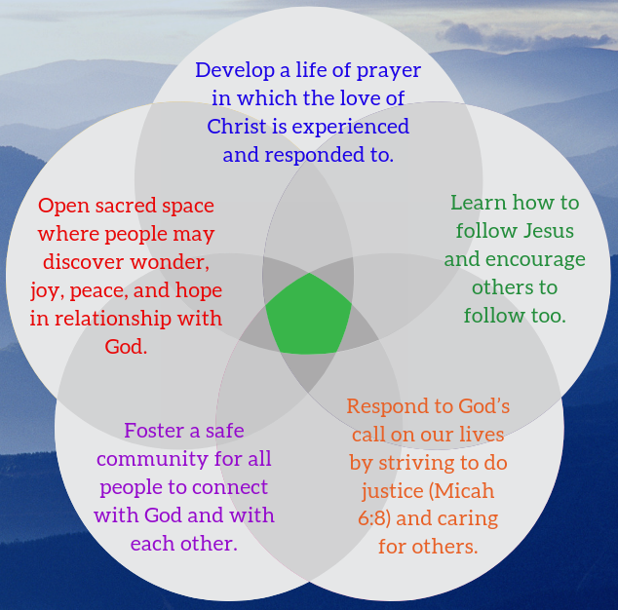
- Develop a life of prayer in which the love of Christ is experienced and responded to.
- Learn how to follow Jesus and encourage others to follow too.
- Respond to God’s call on our lives by striving to do justice (Micah 6:8) and caring for others.
- Foster a safe community for all people to connect with God and with each other.
- Open sacred space where people may discover wonder, joy, peace, and hope in relationship with God.

Growth Intention | Ministry Actions | Progress  October 2019
I. Pathways to community connection  (outward dimension) | 1. Children’s ministry | Children’s ministry discernment group is developing two new ministries for 2020: a combined ministry with the Uniting Church for kids between years 5-8, once a month on the first Sunday of the month to coincide with their Messy Church; and four “soft entry” options aimed at children and families. It’s anticipated the new curate will take point on these.
 | 2. Communications review | Property team is exploring an electronic screen outside.  Website is under review.  We’re hoping to develop a new Parish Life booklet.
 | 3. Music Programme | We now have donation forms for tax deductible donations via the Melbourne Anglican Foundations. Brochures have been developed. The committee has been in conversation with local schools. Development of application pack by the end of October, with intention to distribute to schools in November. Need to plan for the launch of the programme in February 2020.
 | 4. Do Justice | Mission recipients for 2019:  Anglican Board of Missions, Greensborough Plaza Chaplaincy, Anglicare (for homeless women), Brotherhood of St Laurence.  Pathways to Reconciliation Document has been finalized and adopted by Parish Council.  Do Justice with Parish Council support is exploring the possibility of a Yarning Pit.  Disability Inclusion policy is in development and should be complete by the end of 2019.
 | 5. Pastoral Care review | Pastoral Care Team is currently exploring options for how we do pastoral care into the future. It’s expected feedback and involvement from the wider parish in this discernment process will be invited in the coming months.
 | 6. Pathways | The Mission Action Team is currently discerning a Mission Focus Group. We’ll be engaging the whole parish in prayer for this discernment. We’re hoping to ground our work in two bible passages which will be decided at the November meeting. We should have identified our MFG before the 1st February.
II. Growing in faith  (upward dimension) | 1. PRAYER Project | We’ve been using the Prayer for 2019 at services on Sundays.  The Lenten Reflection Booklet was well received and helped us engage with the theme of prayer. Keren did a sermon series on the Lord’s Prayer through Lent.  We held a day of Lament in April.  Dorothy Lee came and unpacked for us the Gospel of Luke in May.  Labyrinth group observed World Labyrinth Day on 5th May.  We participated in the 9 days of prayer for Thy Kingdom Come, and 8 St Margaret’s folk were part of the big celebratory service at the Cathedral.  Week of Prayer for Christian Unity service on 9th June at 4pm.  Midwinter Day of Prayer on 29th June
 | 2. HOLISTIC SMALL GROUPS | Sandra Brown-Holt was appointed small groups coordinator in February.  Sandra has been visiting parish groups.
III. Whole Church Cohension  (inward dimension) | 1. Conducive worship environment | Property team is looking at options to increase efficiency of the sound system.  The hearing loop was moved and fixed in May.  We have remote access now set up for heating in the church.  Training for readers will be provided in the coming months.
 | 2. Combined Sunday services breakfast | These breakfasts continue, thanks to Mitzi and the coordinating team.
 | 3. CHILD SAFE CHURCH | The Child Safe team are moving forward with this. We had have special Child safety focused service on 13th October with awareness raising for all parishioners. In addition to this, there will be two training opportunities for those on rosters on 26th October from 10am-12noon, and on 23rd November from 1pm-3pm. We hope all those on rosters will have their Working With Children and Police Checks done by 24th November.
 | 4. Combined Parish Celebratory Worship  St Margaret’s Day, Pentecost, Bishop’s visit, Planned Giving | We have celebrated the Bishop’s visit on 26th May, and also Pentecost. Planned Giving is happening now, in August, with a celebratory High Tea on 31st August, featuring Cath Connelly playing harp. Our next combined service will be St Margaret’s Day, on 17th November.

