That sheep may safely graze…

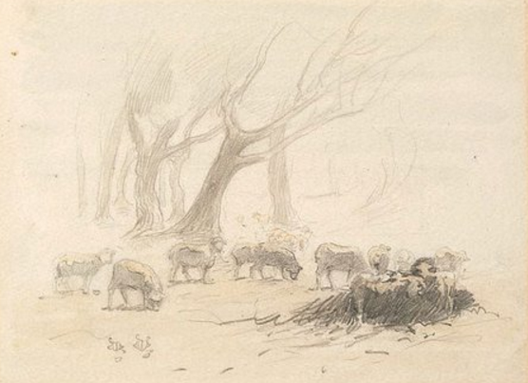
Being a community:
1”Walter Withers, Sheep grazing among trees at Heidelberg (1890)
The sheep that belong to me listen to my voice; I know them and they follow me (John 10:27)

We value the wellbeing of others.
We encourage each other to participate in the life of the church.

We consider the impact of our behaviour on others.

Relating:
We treat each other with respect and dignity, irrespective of ability, gender, sexuality, race, age or contribution to the church.
We act with integrity and honesty in our interactions with each other.

Communicating:
We communicate respectfully with others, and not in a way that threatens, belittles or humiliates.
We speak with integrity and honesty, and refrain from speculation and gossip.

Difference:
We respect those who are different from us and not isolate or ridicule them.
We listen to and seek to understand the beliefs, opinions and practices of others, even when we do not share their views.

Conflict:

We accept responsibility for our part in a conflict.

We are willing to play our part in resolving a conflict.

Based on “Being Together: expectations of behaviour in our church community” – Developed by the General Synod of the Anglican Church in Australia, adapted for our use in our Community St Margaret’s in Eltham.

