ST MARGARET’S ELTHAM

VISION PLAN 2020

VISION:

Making the transforming love of Christ known to all. (Romans 15:13) (Ephesians 3:18)

MISSION:

To make the transforming love of Christ known, we commit ourselves to:
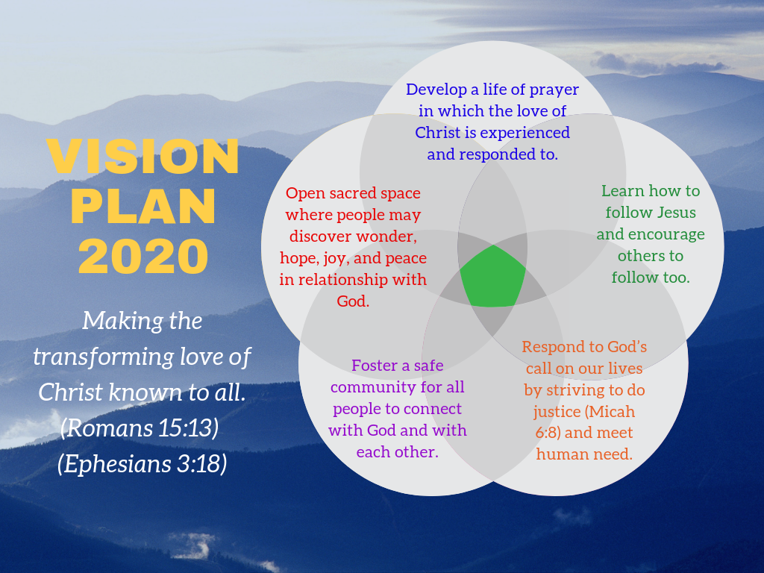
- Develop a life of prayer in which the love of Christ is experienced and responded to.
- Learn how to follow Jesus and encourage others to follow too.
- Respond to God’s call on our lives by striving to do justice (Micah 6:8) and meet human need.
- Foster a safe community for all people to connect with God and with each other.
- Open sacred space where people may discover wonder, hope, joy, and peace in relationship with God.

Growth Intention | Ministry Actions | Steps to achieve | Timeline | Who’s responsible?
I. Pathways to community connection  (outward dimension) | 1. All ages worship service with kids involved in music, reading, have a sermon with kids focus but layered so adults benefit too, or something like Godly play. | - Children’s Ministry Group to analyse the needs analysis document  - Plan and start one child-oriented activity/service | ASAP  Easter 2019 | Shirley, Angela, Sally, Mandy, Melissa, Margaret A, Sandra B-H (Children’s ministry focus group)
 | 2. Focus on marketing and communication of current entry point activities (ie: Taize, Labyrinth, Benedictine Group, Piece of Peace, Meditation, Social justice group etc) | - Develop guidelines for communications  - Plan for marketing activities  - Conduct a review of the website  - Investigate the possibility of having a Screen outside  - Manage the screen in the foyer  - Produce banners for the front board | End of September | Communications Team
 | 3. Music Foundation  Vision: A flourishing music programme in which people are growing in faith in and through St Margaret’s.  Mission: To develop an ongoing music programme which connects people with God.  In short: to establish a Fund/Trust which will fund part scholarships for kids from the local schools, in exchange for the playing in church once a month. It would involve the appointment of a Musical Director, and a series of concerts to raise funds (to contribute towards replenishment of the Fund). (refer to attached document) | - Get background info on Trust/fund and how it would work/be set up.  - Produce brochure for promotion in parish and beyond in time for start of Lent.  - Talk with School Principals re potential connections  - Organise promotion: concert series, launch date etc  - Position Description for Musical Director – draw up and advertise.  - Scholarships for kids available  - Launch | January-February 2019  6th March  March-April  April-May  June-July  from Feb 2020  mid-year 2019 (TBA) | Keren and the wardens
 | 4. Do Justice | - Finalise Pathways (RAP) Document  - Decide allocation of mission giving and report to Parish Council  - Engage in partnerships to further justice initiatives | March Parish Council  February PC  Programme of events to be submitted to March Parish Council | Do Justice Group
 | 5. Pastoral Care | - Review of how pastoral care is done in the parish, including resourcing, models for care for all ages. | August | Pastoral Care Team
II. Growing in faith  (upward dimension) | 1. PRAYER 2019 (see attached document for details)  Vision:  St Margaret’s is a church characterised by prayer, and by a posture of humility before and dependence on God: Lord, teach us to pray.  Mission:  To develop the discipleship of prayer:  - Good teaching on prayer  - Inviting deeper engagement in prayer in a variety of ways  - Prayer in and with our Eltham community | - Write a prayer for the year: “Lord, teach us to pray”.  - Lenten Reflection Booklet.  - Sermon series on the Lord’s Prayer through Lent, on the Eucharist in June-July, and on the sacraments in October.  - Two days of lament: one in Lent, one in November  - Midwinter day of prayer in June  - Luke seminar (Dorothy Lee)  - Reconvene labyrinth group | Complete (01/19)  Lent  As applicable  7th April,  3rd Nov  29th June  4th May  April | Keren  Keren (compiled)  Keren and preachers  Keren and team  Fay Gravenall and friends  Annette Street  Melissa Laidlay, Shirley Nash, and others.
 | 2. HOLISTIC SMALL GROUPS  Work with our small groups to look at health, purpose, connection to wider parish, connection to vision. Parish council to offer support, encouragement, connection with our small groups. | - Appoint a small groups coordinator, and develop a position description for them.  - Develop a template for groups to identify structure, point of contact, vision and mission of group, Funding/budget requirements, and…  - Feed this into a revised Parish Life booklet  - Revise website accordingly | February Parish Coun.  April  June  July-August  August | Sandra Brown-Holt  Small Group coordinator  David and Harry, Annette  Pastoral Care Team
III. Whole Church Cohension  (inward dimension) | 1. Conducive worship environment  - Sound - training announcers (intercessors, readers, those with general notices) how to: project voice, use the microphone effectively (self monitoring of adequate volume  - Live feedback: person at the sounddesk to give feedback. Tell readers that the sounddesk operator will give feedback.  - Offer a further training session possibly one on one? Go to individual readers one by one.  - Heating/cooling in the church | Training workshops: A refresher workshop to be conducted every 6 months  Update Sounddesk instructions and Position Description  Speak to readers about sounddesk operators giving feedback.  One on one training  Install remote access app | March  March  March  March  May | Keren to ask Glenys Collis  John Humann  Mandy (Melissa Quintarelli)  Keren to speak to Glenys and Mandy to speak to Melissa Q.  Property Team
 | 2. Combined Sunday services breakfast to take place on a bimonthly (every two months) basis. | Address marketing of this  Issue good reminders.  SMS to be sent on the Friday. Buddy system to remind people of breakfast who aren’t on mobile? | Every two months | Mitzi, Coralie, and team, Mitzi coordinating
 | 3. CHILD SAFE CHURCH  To implement the Child Safe Standards and be compliant with government and church regulations in respect of child safety. | Sign up with Child Safe organisation  Address Standards 2/3  Address Standard 5  Address Standard 4  Address Standards 6/7  Address Standard 1 | January 2019  February-March  May-June  July-August  November  January 2020 | Keren, David Tuke, Mandy Stevens
 | 4. Combined Parish Celebratory Worship | St Margaret’s Day  Pentecost  Bishop’s visit  Planned Giving | 17th November  9th June  26th May  August | Parish Council  Finance Committee
Structure and Resources
To support this vision and mission the follow subcommittees of PC are involved:
Finance Do Justice Communications (Faith Formation Network)
Property Pastoral Care (Small Groups)

Music Project 2020
Vision: A flourishing music programme in which people are growing in faith in and through St Margaret’s.
Mission: To develop an ongoing music programme which connects people with God.
Aims:
- That it become self-sustaining
- That it be long-term (5-10 years)
- That it produce quality music from a range of church music styles
- To expose more people to church music
- That it be evangelical in purpose
- That leaders be raised up and trained in music and in other areas (that there be intentional mentoring of leaders)
- To connect with the wider Eltham community
- To train more church musicians
- To provide a gift to the wider church of trained and equipped musicians to lead worship
- To contribute to the Arts in the wider community of Eltham and beyond
Ideals
- A Music Foundation or Trust to fund the initiative
- A Musical Director be appointed in a part time capacity
- Part scholarships to be offered to young people (highschool and uni students) in instruments and voice in exchange for playing in church and being involved in performances throughout the year
- The establishment of a youth choir
- The gathering of a group of adult singers from the existing congregation
- Potential funding avenues:
  - A series of concerts by outside, professional groups to promote the Trust/Fund
  - An annual series of concerts by scholarship recipients and the Musical Director to contribute funds back to the Fund
- Opportunities for faith formation (in and through the music programme, as well as in other groups, eg confirmation), including opportunities for faith formation and engagement with families of the young people involved in the music programme
- Opportunities for exposure experiences (Cathedral, CCSY, other churches)
Avenues to explore
- PD for MD
- Talk to Phillip Nicholls and someone involved with the Cathedral Voices re Trust/Fund
- Get legal advice in setting up Trust and scholarship conditions
- Promotion through concert series, paper, FB, social media etc.
- Talk to school principals – Eltham College, Eltham North PS, Monty S and Monty PS, the private college up near Research, RMIT up at Diamond Creek, La Trobe Uni.
Timeframes
- Get background info on Trust/fund and how it would work/be set up. January-February 2019
- Produce brochure for promotion in parish and beyond in time for start of Lent.
- Talk with School Principals re potential connections March-April
- Organise promotion: concert series, launch date etc for 2020. April-May
- PD for MD – draw up and advertise. June-July?
- Scholarships for kids available from Feb 2020
- Launch mid-year 2019?

PRAYER 2019
Vision
St Margaret’s is a church characterised by prayer, and by a posture of humility before and dependence on God: Lord, teach us to pray.
Mission
To develop the discipleship of prayer:
- Good teaching on prayer
- Inviting deeper engagement in prayer in a variety of ways
- Prayer in and with our Eltham community
Actions
- Write a prayer for the year: “Lord, teach us to pray”.
- Develop a brochure advertising the theme for the year (see next page).
- Lenten Reflection booklet 2019
- Sermon series on the Lord’s Prayer through Lent
- Two days of lament: one in Lent, one in November
- Midwinter day of prayer in June
- Series on the Eucharist as prayer June-July
- Labyrinth days?
- Other experiential days, eg a lectio divina session? Meditation community opportunities?
- Reflections series through Easter
- Revise parish prayer list and encourage use
- Intercessors’ workshop(s) – 2nd March
- Home communion/extended communion workshop 2nd February
- Vicar and ministry staff to walk the streets to connect with community and offer to pray for our wider community – March and July. Special prayers/spaces in services to allow those prayers.
- Revise how prayers are recorded in pew sheet (eg years’ mind, long term sick, etc)
- Sermon series on the minor sacraments in October
- Focus on different prayer disciplines – daily office, daily quiet time etc.
- Promote Saturday evening prayer group.
- Promote seriousness of prayer for the parish – emails when there are significant parish events?
- Invite parishioners to ask a friend/neighbour for what they can pray for them, and report back. Do this four times in the year. Do something creative.

Prayer 2019
This year at St Margaret’s we’re focusing on the theme of prayer, inviting us into learning about prayer, learning to pray, and deepening our experience of God’s goodness in prayer. Here are some of the opportunities coming up:

World Day of Prayer – Friday 1st March, 10:30am at Our Lady’s Eltham
We join with people from other churches on Friday 1st March at 10:30am to pray for the people of the world.

Lent Reflection Booklet
A number of folk have been invited to contribute to the Lent Reflection Booklet. Last year we used a Catholic resource which had daily reflections. Many people expressed positivity about this, although sometimes the reflections didn’t quite hit the mark. This year we thought we’d do something similar, only with reflections on prayer produced by St Margaret’s people.

Intercessors’ workshop on 23rd March, 1-3pm
Every so often it’s good to touch in with some training. This workshop will be for anyone who leads, or who would like to lead the communal prayers in our services. We’ll explore how to craft intercessions, drawing on the readings of the day, and different approaches, patterns, and styles of leading prayer.

The Lord’s Prayer – Lent series
Through Lent, Keren will be doing a sermon series on the Lord’s Prayer, digging deeper into these so familiar and much loved words. If you miss one of the sermons, they will be available on the website for download.

Easter prayers
Those who haven’t been invited to (or for whatever reason didn’t) contribute to the Lent booklet will be invited to write a short reflection about prayer. These will be presented through Easter season.

Thy Kingdom Come 30th May – 9th June
Two years ago the Archbishop of Canterbury designated the week between Sunday after Ascension and Pentecost as a week of global prayer for the church and that God will grow it in its ministry and mission, touching hearts the world over. This year we’ll join the wave of prayer, which begins on the evening of 30th May with a service at the Cathedral.

Pentecost Prayer
The week between Pentecost and Trinity Sunday is designated as the Week of Prayer for Christian Unity. We’ll be hosting an ecumenical service on the evening of Pentecost June 9th.

Parish Midwinter Prayer Day – 29th June
Last year we had a Midwinter Day of prayer for the parish. This year we’re repeating this day: an opportunity for the parish to gather to hold before God both those things that are on our hearts, as well as to pray for the ministry and mission of the church.

Praying for our community – March and July
In March and July, the vicar and others will be spending some time in Eltham Town Centre and at surrounding businesses, and inviting local folk to offer prayer requests, which will then be offered at the Sunday services on the following Sunday. Those who submit the requests will be invited to come along on the day we offer those prayers.

Praying for our neighbours near and far
Last year’s Prayer Buddies will continue seasonally. And as an addition, four times this year we’ll be invited to bring a prayer request from a friend or neighbour (and maybe even the friend or neighbour!).

Understanding the Great Thanksgiving
The Eucharist (Greek for “thanksgiving”) is essentially a prayer. Our whole service of worship is a corporate expression of prayer and praise to God our Creator, Redeemer, and Sanctifier. In late June and early July the vicar will present a series of four services/sermons explaining the bits and pieces, the whys and wherefores of the service.

Services of Lament – 7th April and 3rd November
Throughout the scriptures lament goes alongside rejoicing. It’s important that we have times and seasons for mourning and repenting, as well as for celebrating and rejoicing in God’s goodness. When we lament, we join our own sorrow to the sorrow of others, and on behalf of a world in need of God’s peace and reconciliation. The service of lament on 7th April will have a Lenten focus, an opportunity to engage in repentance. The service on the 3rd November will be one focussing on remembering our loved ones who have died, an All Souls commemoration as well as healing service. The theme of lament and allowing space for the solidarity with suffering also accords with the Diocesan Vision.

Prayer 2019
Lord, teach us to pray.
Teach us to listen to your voice
and to hear your word.
Teach us to offer our hearts to you in love
and to know your love.
Teach us to forgive
and be forgiven.
Teach us to give our lives in your service
and to do your will.
Teach us to pray,
and pray in us, Lord Jesus. Amen.

